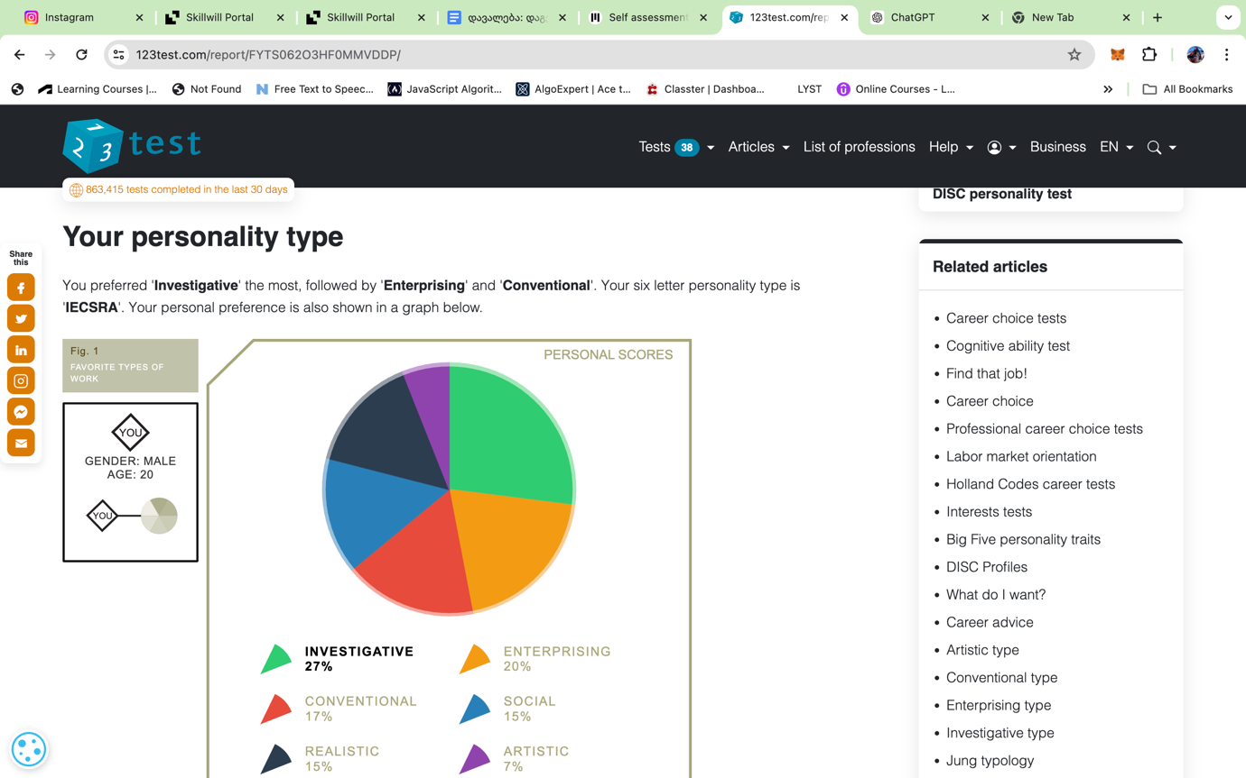

**Specific**

I want to become a proficient Python developer by completing SkillWill Python course, practicing coding daily, and building projects.

### Measurable

I will measure my progress by:

1. Completing 95% of the course exercises.
2. Coding for at least 30 minutes daily.

### Attainable

This goal is attainable because I have a basic understanding of Python, access to online resources, and can dedicate 30 minutes daily to practice.

### Relevant

Becoming a Python developer aligns with my career goals in technology and will enhance my programming skills, making me more competitive for internships and job opportunities.

**Time-Based**

I will achieve this goal in five months:

1. Complete the online course in five months.